

STAPLES PROMOTIONAL PRODUCTS SUPPLIER ROUTING GUIDE
Last Revision: September 2022

SPP Approver: Andrew Moore

Dear Valued Supplier:

This letter is intended to notify your organization of changes to the new procedures and requirements for handling shipments for Staples Promotional Product (SPP) Purchase Orders. Since its last incarnation the subsequent SPP Supplier Routing Guide has undergone changes.

- Ground Parcel shipments: Notated on SPP’s PO
- Air Parcel shipments: Notated on SPP’s PO
- LTL Routing Matrix – TForce Freight or YRC Freight (includes Penn, Holland, Reddaway) only
- Notate LTL BOL address information, page 5
- TL (10 PLTS or more) email freightrouting@staples.com
- SPP has multiple carrier accounts, be sure to use the carrier account notated on the PO
- New Freight Terms, page 3

All other PO’s will ship parcel on the client’s account (vendors will be fined entire freight amount if incorrect carrier account number is used – SPP’s PO clearly indicates carrier account number to be used.
LTL shipments: LTL shipments, the weight has been changed to 500 lbs.
- SPP’s LTL Matrix is to be adhered for 501 – 8,000 lbs. or 9 pallets or less
- If a carrier not indicated on SPP’s Matrix, is utilized, and billed to SPP, vendors will be fined entire freight amount SPP is invoiced.

Please review and familiarize your team with these revised requirements. The LTL routing matrix was revised 09/01/21 and is to be utilized moving forward. It is essential to our continued growth and success that our partners support these initiatives and changes. If you have any questions regarding the new procedures or enclosed documents, please feel free to contact the Staples Promotional Products Traffic and Logistics team by phone or email at freightrouting@staples.com

Sincerely,



Andrew Moore
Manager, Traffic and Logistics

Contents

- SPP SUPPLIER DOMESTIC ROUTING REQUIREMENTS 1
Table 1: SPP Supplier Shipment Categories 2
  - Small Package or Parcel Shipments 2
Illustration 1: Sample Purchase Order; Shipping Instructions 3
  - Less than Truckload (LTL) Shipments are to be routed per ‘Staples Promo Products LTL Routing Matrix 09/01/21.xlsx’ 4
  - Truckload (TL) Shipments 5
- SPP SUPPLIER INTERNATIONAL ROUTING REQUIREMENTS 6
  - Imports to the United States 6
  - Exports from the United States 7
- PALLETIZATION AND TRAILER LOADING: 8
  - Pallet Specifications 8
Illustration 2: Acceptable Four-Way 40”x48” Pallet 8
  - Pallet Loading Specifications 9
  - Pallet Configuration Requirements 10
  - Truckload (TL) Trailer Loading 11
Illustration 3: Truck Loading Diagram 11
  - Additional Requirements 12
- DAMAGES 13
- ADDITIONAL ROUTING EXPECTATIONS 13
  - Shipment Paperwork 13
Illustration 4: FedEx Shipping Label example with Reference to PO 14
  - On Time Shipping & Shipment Expediting 15
  - Truckload (TL) Shipment Routing (SPP Traffic & Logistics) at freightrouting@staples.com 16
  - Less than Truckload (LTL) Shipment Routing (Direct Carrier Scheduling) 17
  - Expedited Less than Truckload (LTL) Shipment Routing 17
- DEFINITIONS 18
APPENDIX A: LTL or TL SHIPMENT BILL OF LADING (BOL) EXAMPLE 19
APPENDIX B: SPP SUPPLIER ROUTING REQUEST FORM EXAMPLE 20

SPP Supplier Routing Guide iii | c o n t e n t s

SPP SUPPLIER DOMESTIC ROUTING REQUIREMENTS

All suppliers are responsible for shipping in accordance with Department of Transportation (DOT), PHMSA (Pipeline and Hazardous Materials Safety Administration) and IATA (International Air Transport Association) standards for all products classified as Hazardous Materials. This includes proper labeling and applies to both Air and Ground Shipments.

SPP will hold all suppliers responsible for failure to ship according to these requirements. Failure to comply with these shipping requirements will result in a breach of the Supplier Agreement between the parties and will result in a minimum fine of $1500.00 per violation, per tracking number. Under no
circumstance should any supplier ship products containing lithium batteries on any SPP LTL Carrier’s Account number or SPP’s Customers freight account number.

This document supersedes any instructions and or notes on all Staples Promotional Products purchase orders. This document also applies to international shipments as well as all orders shipped in the United States and Canada.

Transporting Hazardous Materials or Dangerous Goods are to be shipped on the vendor’s freight account. It is the vendors responsibility to conform to the regulations published by IATA &/or PHMSA. The safe transport of hazardous material and dangerous goods contents is the legal responsibility of the shipper.
Vendor shall bill SPP their discounted freight. Published rates will not be accepted. Shipper is to ship on shippers account, be the importer or record, responsible to duties and taxes and only bill SPP their discounted rates. If the above is not adhered to, vendor violations will be filed.

Staples Promotional Products will not pay any domestic freight charges from a supplier where an account number or 3rd party billing information was provided on the Purchase Order.
For routing SPP Purchase Orders, shipments have been broken down into four primary shipment categories which are as follows:

Table 1: SPP Supplier Shipment Categories
 | Shipment Type | U.S Origin/ Destinations | Weight | Pallet  Positions | Approved  Carrier | Requirement
A. | Small Package or Parcel  Ground UPS  (Not on pallets) | ALL | < 501 lbs. | None | UPS Parcel (UPSC) | Supplier contacts carrier direct for pickup
B. | Small Package or Parcel  Air FedEx  (Not on pallets) | ALL | < 501 lbs. | None | FedEx  Parcel (FDEN) | Supplier contacts carrier direct for pickup
C. | LTL - (on pallets)  SPP Routing Matrix | ALL | 501-8,000 lbs. | 1 to 9 | Refer to Routing Matrix | Supplier contacts carrier direct for pickup
D. | Truckload (TL) | ALL | > 8,000 lbs. | 10 or More | TBD | Supplier submits routing requests and form to  freightrouting@staples.com

Small Package or Parcel Shipments
  - Definition: Shipments less than 501 lbs.
  - Supplier Routing Requirement:
  - Supplier schedules shipment directly with UPS parcel for Ground
  - Supplier schedules shipment directly with FedEx parcel for Air
  - Origin/Destination: ALL (Domestic U.S.)
  - Approved Ground Parcel Carrier: UPS parcel Ground 800-877-1497
  - Approved Air Parcel Carrier FedEx parcel Air 800-463-3339

  - Freight Terms:

    - 3rd PARTY BILL to all destinations - (SPP utilizes multiple parcel accounts*)

    - Note if it is SPP’s carrier account OR Clients 3PB account number notated on PO*

    - Account Numbers - As directed on individual PO’s

EXCEPTION: Would be if supplier is providing FREE freight or shipping 3PB on client’s account

- Referencing: SPP PO# must appear in the first carrier reference field

* VIOLATIONS WILL RESULT IN A SUPPLIER FINE.
(Refer to Supplier Compliance Guide for amounts)

Illustration 1: Sample Purchase Order; Shipping Instructions

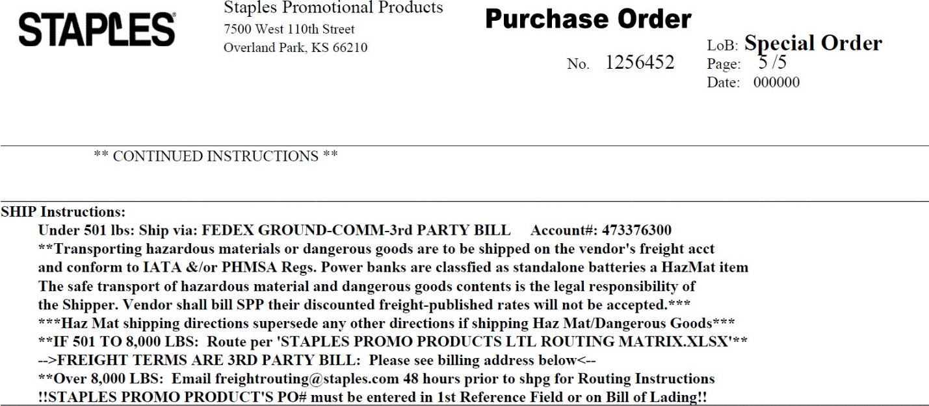
Look at all pages

Look at all pages for Shipping Instructions

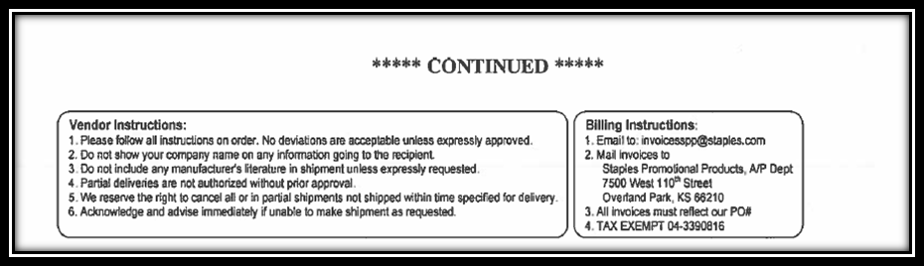

Look at all pages

Look at all pages for Shipping Instructions

- LTL - Less than Truckload Palletized Shipments are to be routed per:
a. ‘Staples Promo Products LTL Routing Matrix 09/01/21.xlsx’

  - Definition: Shipments 1 to 9 pallets or between 501 and 8,000 lbs.
  - Origin/Destination: ALL (Domestic U.S.)
  - Supplier Routing Requirement: Supplier schedules shipment directly with appropriate LTL carrier
  - Supplier obtains PO #, Contact Name & Phone # for receiver from requester, notates on BOL
  - Approved Carriers: Identified in ‘Staples Promo Products LTL Routing Matrix 09/01/21.xlsx’
  - Carrier Service Type: Standard unless noted in routing guide
  - Scheduling Pickup:
Carrier contact info found in:
‘Staples Promo Products LTL Routing Matrix 09/01/21.xlsx’

  - Freight Terms: Standard VICS BOL (supplied by SPP) must read (SEE APPENDIX A)
  - ALL BOL’s must have this address
    - Unless 3rd party on Clients Account – email “ordered by” for further instructions
    - Otherwise, shipper will be responsible for freight charges
3rd Party Bill to:
Staples Promotional Products Accounts Payable
7500 West 110th Street Overland Park, KS 66210

VIOLATIONS WILL RESULT IN A SUPPLIER FINE.

- Truckload (TL) Shipments
  - Definition: Shipments containing 10 or more pallet positions and/or greater than 8,000 lbs.
  - Origin/Destination: ALL (Domestic U.S.)
  - Supplier Routing Requirement:
  - Supplier submits completed SPP Routing Request Form (SEE APPENDIX B) to
  - freightrouting@staples.com

  - Approved Carrier: To Be Determined by SPP Logistics freightrouting@staples.com
  - Freight Terms: Standard VICS BOL (supplied by SPP) must read (SEE APPENDIX A)
3rd Party Bill to:
Staples Promotional Products Accounts Payable
7500 West 110th Street Overland Park, KS 66210

VIOLATIONS WILL RESULST IN A SUPPLIER FINE

SPP SUPPLIER INTERNATIONAL ROUTING REQUIREMENTS
SPP has very different policies for shipments importing to the United States versus shipments exporting from the United States. Please ensure your support teams clearly understand SPP directives.

Imports to the United States
- Definition: Shipments moving from a foreign location into the United States
- Supplier Routing Requirement: SPP will only purchase products on FCA, Free Carrier US location as defined by Incoterms 2010 basis. All pricing quoted to SPP must be predicated on making the goods available to SPP at an US origin. SPP will not at any time act as the Importer of Record for a shipment into the United States. Supplier’s pricing to SPP is required to be complete to the US location where SPP will take possession of the shipment. Supplier must use their own freight account and act as the Importer of Record, IOR, or arrange for an agent to act as the IOR on the supplier’s behalf. SPP will not be responsible for any expenses resulting from the supplier improperly completing the commercial documents and / or shipping documents for a shipment imported to the United States
- Origin/Destination: Foreign location/US location
- Approved Carrier: Suppliers carrier
- Carrier Service Type: Suppliers choice bearing in mind PO in-hands date
- Freight Terms: Prepaid by Supplier

* VIOLATIONS WILL RESULT IN A SUPPLIER FINE. (Refer to Supplier Compliance Guide for amounts)

Exports from the United States
- Definition: Shipments moving from the United States to a foreign location (inclusive of Puerto Rico, US Virgin Islands, and other US territories and commonwealths). For all shipments of SPP orders from the United States to a foreign location SPP is the USPPI / Exporter of Record,

supplier is not authorized to act as such on SPP’s behalf
- The Export Team will request Export Routing Requirements (see below) from the shipper before routing can be provided. The Export Team will respond the same day or within 48 hours of receiving below information for routing instructions.
- Supplier Export Routing Requirement (48-hour advanced notice required):
    - SPP PO
    - Date Available
    - US zip code the order will be shipping from
    - Country of origin (manufacture) of the product
    - Number of shipping cartons / pallets
    - Weight of each shipping carton / pallet
    - Dimensions of each shipping carton / pallet
- Origin/Destination: US location/Foreign destination
- Approved Carrier: To Be Determined by SPP Export Routing
- Carrier Service Type: To Be Determined by SPP Export Routing
- Commercial Documents / Routing Instructions: To Be Provided by SPP Export Routing
  - In the case that an AES filing is required SPP will file our own entries and will always provide an ITN number. It is expected the supplier will correctly enter this information in their shipping system when processing the shipment
- Regulations: SPP operates in accordance to the US Export Administration Regulations. As SPP’s supplier you are expected as comply with these regulations as well. SPP will not be responsible for any expenses resulting from the supplier improperly following the directive provided to them by the SPP Export Routing team
- Supplier is not to export product without SPP’s Foreign Commercial Documents
- Supplier is not to enter or create electronic invoices in the FedEx, UPS or DHL systems where SPP has or will supply the Foreign Commercial Documents
- Where a single order must be broken into multiple cartons for shipment to a single location, it is to be shipped as a single multi-carton shipment and not as multiple single carton shipments.
- Freight Estimates: Vendor should direct all enquiries to the SPP Export Routing team at exportrouting@staples.com

Domestic LTL Shipments: From the US to the US
- Follow SPP’s Matrix

PALLETIZATION AND TRAILER LOADING:
All shipments, excluding expedited and small package/parcel shipments, must be palletized and adhere to the specifications outlined below unless prior authorization is obtained from Ordered By as indicated on PO to ship floor loaded. All additional agreements must be made in writing.

Pallet Specifications
- Size: 40”x48”
- Pallet Entry: All pallets must be accessible from all four sides
- Not acceptable: Block, cardboard, and winged pallets

No pallet exchange programs
- Pallets must be provided at no charge
- Pallet Standards for Construction 40”x48”: Pallets for domestic shipments must be GMA, hard wood (#1) or grade “A” pallets. Pallets for export shipments must meet ISPM 15 standards and must email exportrouting@staples.com before shipping.
- All pallets must meet the standards noted below:
    - Structural Soundness – minimum 95% hardwood
    - Lead boards – Top and Bottom – minimum 5 ½”
    - Plating – no more than 1 per stringer
    - Top Boards – maximum 3 ½” spacing
    - Stringer – minimum 1 3/8” x 3 ½” x 48”
    - No Boards overhanging stringers
    - Deck Boards – minimum 5/8” thick
    - All nails flush or countersunk
    - 5 Bottom deckboards

Illustration 2: Acceptable Four-Way 40”x 48” Pallet
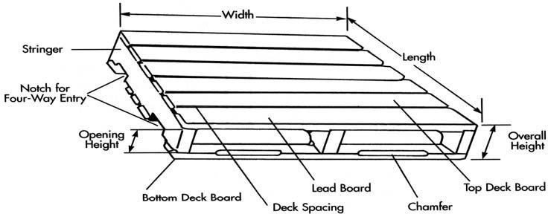

Pallet Loading Specifications
Vendor loading requirements are designed to maximize freight efficiencies. Palletized product is classified in general categories, based on the type of goods being shipped. SPP requires pallet positions to be fully utilized up to a height of 86 inches whenever feasible.

Single SKU Pallets:
- A Single SKU Pallet is a fully loaded pallet comprised of only one SKU
- Single SKU pallets can be up to 86” in height, including the height of the pallet

Double Stackable Freight LTL only:
- SPP requires that a double stack pallet have a cap sheet on all pallets
- Exceptions include high weight product. If product can be double stacked without damage to the product, it does not qualify for a height exemption due to weight
- Maximum height of Single SKU, double stacked pallets including the pallets: 52” for ALL locations
- All other exemptions to the double stacking and pallet height requirements must be reviewed with SPP Traffic and Logistics and or Export Routing teams prior to commencing shipment of that product
- Contact your SPP Traffic and Logistics team at freightrouting@staples.com
or
- Export team at exportrouting@staples.com for shipments exporting out of the US

High Weight Freight:
- Where the total weight, including the pallet, exceeds 1,500 pounds, the product is a high weight SKU and not able to be double stacked
- Single SKU pallets of high weight product can be stacked to 86” in height, including the height of the pallet. These pallets must not exceed a total pallet weight of 2,500 pounds, including the pallet

Mixed SKU and/or Mixed PO Pallets:
- A Mixed SKU Pallet is a pallet comprised of more than one SKU. A Mixed PO Pallet is a pallet comprised of more than one PO
- When shipping Mixed pallets, pallets must be boldly marked “MULTIPLE ORDERS” or “MIXED PALLET” (at least once on the shrink wrap and once on box with the packing list)
- When shipping Mixed pallets, the maximum single pallet height requirement will be waived in order to gain freight efficiencies, provided no single SKU or PO on the pallet is stacked higher than 52 inches
- Maximum height of Mixed pallets, including the pallet: 86” for ALL locations
- Maximum weight of Mixed pallet is 2,500 lbs.
- When assembling a Mixed pallet, heavier product must be stacked on the bottom and lighter product on top

General Pallet loading requirements:
- Improving freight efficiency is a collaborative effort between SPP and our supplier partners.
- Additional palletization and loading exceptions may apply, e.g., certain high cube/low weight, oversized, or floor-loaded items
- Exceptions will be reviewed by SPP Traffic and Logistics. Please contact your SPP Traffic and Logistics team at freightrouting@staples.com

Pallet Configuration Requirements
- Pallet Layering: Pallets must be layered, or grouped, by SKU. Tiers must be interlocked and identical throughout the pallet for like-sku pallets
- Stacking: It is not acceptable to stack pallets. Product cannot be stacked around the
edge of the pallet with the middle left empty
- Pallet Wrapping: Pallets must be securely stretch wrapped to ensure that the pallet arrives intact at destination. Clear stretch wrap should be used to wrap a pallet. Colored or tinted stretch wrap is not acceptable. When securing pallets, use 57 Gauge shrink wrap and ensure the shrink wrap overlaps the pallet and the product, securing the product to the pallet. It is also suggested that the pallet be wrapped in a ‘bowtie’ or ‘roping’ method and that ample layers of wrap are utilized to maintain the integrity of the pallet
- Metal Banding / Strapping: Use of metal banding / strapping for any reason is prohibited. SPP facilities do not have the tools necessary to safely handle, remove and dispose of the metal banding. SPP is committed to conducting our business in a manner that is safe for our Associates, our Customers, and the Communities in which we operate
- Overhang: Product must not extend past the edge of the pallet to minimize product damage during transit
- Multiple Purchase Orders: Multiple POs may be placed on the same pallet but must be clearly separated. Backorders must be separated and clearly marked with the PO and SKU

Truckload (TL) Trailer Loading
- Load security: Suppliers are responsible for loading trailers in a manner which minimizes shifting and damage under normal transportation conditions. Blocking and bracing is the responsibility of the shipper
- Floor loading: If the product has been granted an exception for floor loading, the product must be segregated by SKU and PO within the trailer

Pallet loading:
  - 102” wide trailers: Pallets should be loaded sideways with the 48” side against the back of the trailer (30 pallets will fit on a 53’ trailer). Exceptions based on non-standard pallet sizes or loaded dimensions must be reviewed with the SPP’s Logistics department
  - Less than 102” wide trailers: pallets should be “Pin wheeled”. One pallet is positioned straight in with the 48” side against the back and the other pallet is sideways with the 40” side against the back of the trailer
- Non-Standard Pallet Configuration: If using non-standard pallet configurations (any pallet that is not 40”x48”), it may not be possible to load TURNED. In this case, please seek guidance from SPP Traffic and Logistics to address the specific needs and characteristics of your shipment

Illustration 3: Truck Loading Diagram
53foot truck
110" high
102" wide
636" length
40" 48"
48" 40"
40" 48"
48" 40"
40" 48"
48" 40"
40" 48"
48" 40"
40" 48"
48" 40"
40" 48"
48" 40"
40" 48"
48" 40"
48" 48"
48" 48"
48" 48"
48" 48"
48" 48"
48" 48"
48" 48"
48" 48"
48" 48"
48" 48"
48" 48"
48" 48"
48" 48"
40" 40"
40" 40"
40" 40"
40" 40"
40" 40"
40" 40"
40" 40"
40" 40"
40" 40"
40" 40"
40" 40"
40" 40"
40" 40"
40" 40"
40" 40"
T
o t a
l
Straight
26 pallet load
T
o t a
l
Pin wheeled
28 Pallet load
Turned
30 pallet load
Length 40
Width 48
Length 48
Width 40
T
o t a
l
Length 40
Width 48
Length 40
Width 48
624"
/
12"
l l 52'
p
a l
p
a l
Length 48
Width 40
Length 40
Width 48
p
a l
Length 40
Width 48
Length 40
Width 48
L
e n g h
t 624"
616"
/
12"
l l 51'
L
e n g h
t 616"
Length 40 Length 48
Width 48 Width 40
600"
/ 12"
l l
50'
Length 40 Length 40
Width 48 Width 48
Length 48
Width 40
Length 40
Width 48
L
e n g h
t 600"
Length 40
Width 48
Length 40
Width 48
Total Pallet Width 80" Total Pallet Width 88" Total Pallet Width 96"
102" - 80" = 22" 102" - 88" = 14" 102" - 96" = 6"

Length 48 Length 48
Width 40 Width 40
Length 48
Width 40
Length 48
Width 40
Length 48
Width 40
Length 48
Width 40

Additional Requirements

- Multi-stop Shipments: SPP may consolidate LTL shipments from 2 or more shippers into a truckload. When this occurs, the shipper should adhere to the following:
    - Loading sequence - If the routing status indicates that the trailer will make a second or third pickup, the initial supplier is required to place its shipment in the nose of the trailer. If the supplier entered the shipment as stackable, the product must be stacked in order to make room for the additional stops. Each stop needs to ensure their shipment has been braced appropriately with dunnage, or some other means, to secure the shipment in route to the following pickups.
    - Previously loaded pallets - The second or third shipper should not remove any previously loaded merchandise. Product previously loaded onto a trailer is to remain intact.
    - Insufficient space on trailer - Should the remaining space on the trailer be insufficient for the entire shipment, contact SPP Traffic and Logistics immediately. The second or third shipper should not ship a partial shipment.
    - Seal Control – The shipper / supplier must provide and apply a seal on all shipments moving on truckload carriers and notate the seal number on the BOL.
      - When a sealed trailer arrives at your location to pick up as part of a multi-stop, PRIOR to breaking the seal to load your product, compare the seal number on the trailer to the seal number listed on the BOL from the carrier’s last pickup.
      - If the seal numbers match, break the seal, load your freight, affix your seal to the trailer and notate that seal number on the BOL.
      - If the seal number from the previous pickup does not match or the driver refuses to show the BOL from the last pickup, contact the SPP Traffic and Logistics department immediately via email at freightrouting@staples.com.
- Loading time – Suppliers are allowed two hours of carrier detention at origin. Detention beyond two hours will be charged back to the supplier. In order to ensure carriers are not erroneously billing detention charges at pickup, and to ensure those erroneous charges are not passed on to the shipper, SPP is making the following commitments:
- Detention charges will not be assessed if the carrier is late for the scheduled pickup appointment.
- Any detention charge that is billed to SPP beyond 90 days will not be assessed against a supplier.
- If a carrier arrives early, detention charges will not begin until 2 hours after the scheduled pickup time, not carrier arrival time.

DAMAGES
Any damages incurred because freight was not properly loaded and/or secured by the supplier will be the responsibility of the supplier regardless if SPP’s carrier was used. Return Authorizations will be requested or the cost of the damaged product + freight will be deducted from the invoice.

ADDITIONAL ROUTING EXPECTATIONS

Shipment Paperwork
- Packing List
  - Must be
    - INSIDE the 1st or last carton ---- OR ----
    - in a Packing List envelope securely attached to the 1st or last carton (Example: Carton 1 of 10 or Carton 10 of 10)
  - The carton containing the Packing List must be clearly marked ‘PACKING LIST ENCLOSED’
  - Packing List must meet the standards noted below:

SPP PO(s)
    - Total quantity shipped
      - Apparel – quantity of each size and color shipped
    - Quantity per carton
    - Total shipment carton count
    - Order complete indication
    - Total shipment weight
- Small Package or Parcel Shipments
  - SPP is self-insured. It is never acceptable to indicate a declared value and thereby cause SPP to incur additional insurance charges without the direct written authorization of the Ordered By as indicated on the PO, or by the SPP Traffic and Logistics team

Must have SPP’s PO referenced in the first carrier parcel reference field
  - PO should be listed in this field by itself with no other information; do not include punctuations, spaces or any letters. Do not reference the PO in the ship-to address Reference field should read as ‘1234567’
  - VIOLATIONS WILL RESULT IN A SUPPLIER FINE. (Refer to Supplier Compliance Guide for amounts)

    - (Illustration below)
- Vendor Case Quantity Consistency (VCQ)
  - Based on packing details loaded in InfoShare (PIM)
  - For stock inventory items ONLY

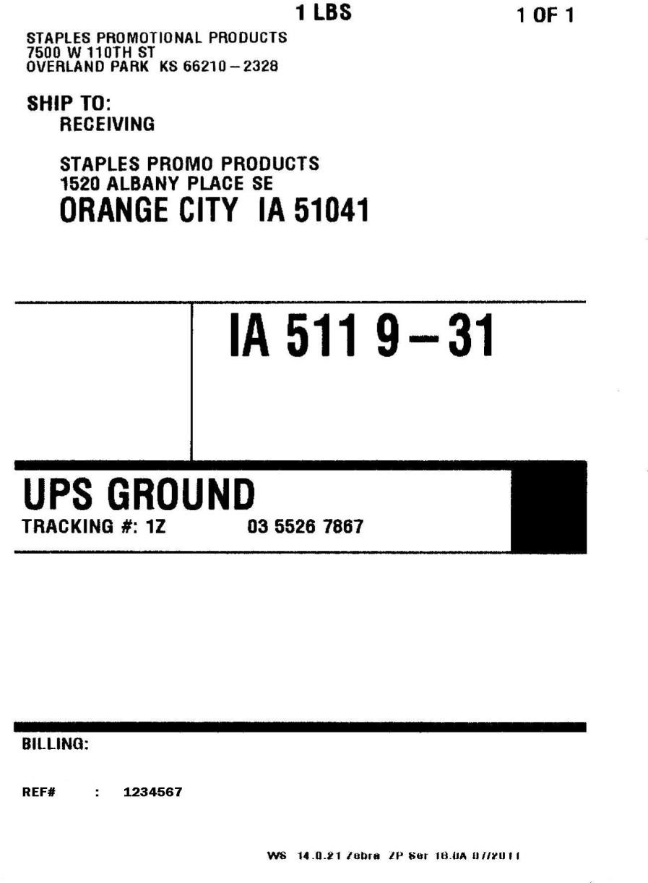
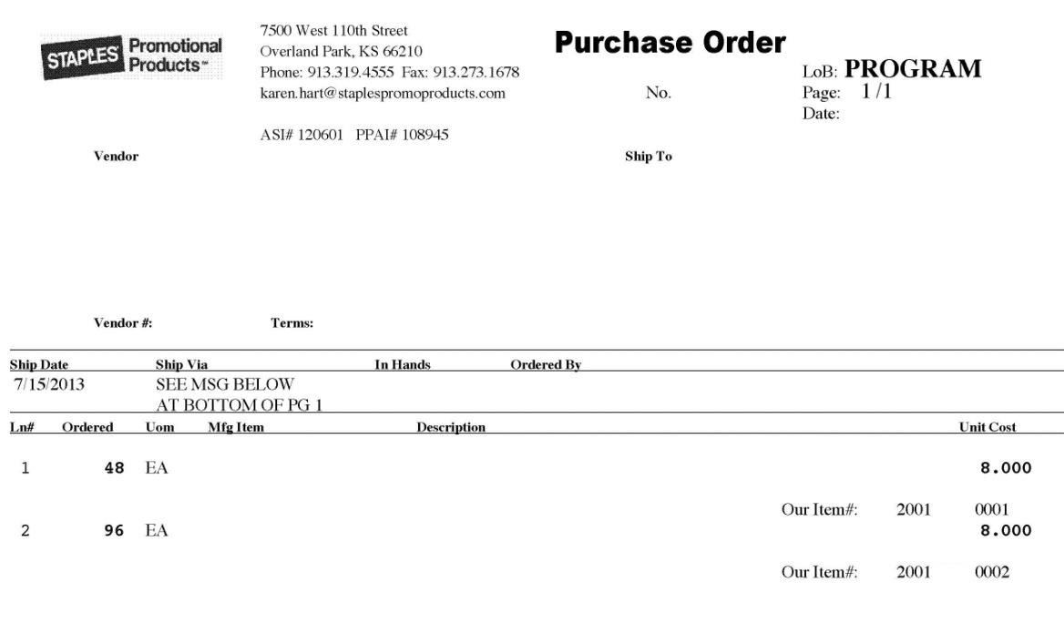
Illustration 4: Shipping Label example with Reference to PO
7
123456

- LTL/TL Standard VICS Bill of Lading (BOL) SPP Supplies - In addition to standard packing lists and other shipment documentation, both LTL and TL shipments must include a Standard VICS Bill of Lading (BOL) (SPP supplies) with the following information clearly detailed within the document: (SEE APPENDIX A)

SPP PO
- Proper Bill-To information
- Complete (ship from and to) addresses including phone numbers
- Cartons per PO
- Total number of cartons
- Total handling units/pallets
- Proper Commodity Description
- NMFC Number and sub class (for LTL shipments)
- Freight Class (for LTL shipments)
- Weight (pallet weight to be included)
- Carrier will need to sign for carton count
- * VIOLATIONS WILL RESULT IN A SUPPLIER FINE. (Refer to Supplier Compliance Guide for amounts)

On Time Shipping & Shipment Expediting
The expectation is the supplier will provide a delivery date at the time the order is placed. It is the responsibility of the Supplier to ship allowing sufficient time to meet PO In-Hands Date requirements. Any delays from the requested in hands date must be discussed with the Ordered By/Requester indicated on the SPP PO. The supplier does not have the authority to expedite freight unless they are taking responsibility for the freight charges; SPP will not pay for expedited freight charges on shipments that were not authorized in writing prior to shipping. It is the responsibility of the supplier to contact the Ordered By/Requester indicated on the SPP PO when an order will be completed and ready to ship early enough that shipping via the service level indicated on the PO would cause it to arrive at destination prior to the PO In Hands date. Because of the nature of our business there are times it is not acceptable to arrive before required in hands date. The Ordered By/Requester must have the opportunity to assess if a slower service level is appropriate.

If in doubt to meet PO In-Hands Date, it is the shipper’s responsibility to complete and email SPP’s
Routing Request form for each shipment/location in question.

  - Truckload (TL) Shipment Routing (SPP Traffic & Logistics)
- Route freight as soon as possible provided the load information is accurate and complete
- At a minimum, routing request should be submitted for SPP PO’s 48 hours prior to availability
for pickup/shipment
- If the SPP supplier is unable to submit a routing request for the shipment 48 hours prior to the expected ship date, the Supplier should notify the Ordered By indicated on the SPP PO prior to, and as soon as it is known that the PO cannot ship in time to meet the required in hands date.
- Upon submission of the completed routing request form (SEE APPENDIX B) to the SPP Traffic and Logistics team, the shipment will be routed based upon best mode and price.
- Once confirmed the supplier will receive notification via email confirming the pickup appointment day and time as well as a completed Bill of Lading. This is the Bill of Lading to be used when shipping the order, no exceptions.
- Please note that it can take up to 48 hours to receive a reply from the SPP Traffic and Logistics Freight Routing team based upon their ability to assign a carrier to the load. Plan appropriately!

Less than Truckload (LTL) Shipment Routing (Direct Carrier Scheduling)
- Shipper is to contact LTL carrier as soon as possible to schedule pickup provided the load information is accurate and complete. Please refer to Staples Promo Products LTL Routing Matrix 09/01/21.
- It is recommended that the preferred LTL carrier should be contacted as soon as possible or 24 hours in advance, to schedule pickup of the shipment.
- If the SPP supplier is unable to schedule shipment and meet the required in hands date, the Supplier should notify the Ordered By/Requester indicated on the SPP PO prior to, and as soon as it is known that the PO cannot ship by the required in hands date.

Expedited Less than Truckload (LTL) Shipment Routing
- If it is believed the standard LTL service will not accommodate the PO In Hands date on the PO the supplier is to contact freightrouting@staples.com immediately with a completed routing request form indicating there is a problem meeting the in hands date and asking for assistance in expediting the shipment. It is never okay to ship prior to obtaining SPP’s approval for expediting an order. In addition, the following steps must be taken:
    - Notify Ordered By/Requester indicated on the SPP PO
    - Get written approval for expedited shipping service from SPP purchase order Ordered By/Requester or freightrouting@staples.com if it is determined that expedited shipping is warranted to meet customer expectations

DEFINITIONS
- Date Available – The date that the product is, or will be, available for pickup
- In Hands Date – The date indicated on the Purchase Order as when the shipment is expected to be delivered to the specified destination
- Mixed PO Pallet – A pallet comprised of more than one PO. A mixed PO Pallet could contain a single SKU
or Mixed SKU’s
- Mixed SKU Pallet – A pallet comprised of more than one SKU
- Pallets - the total number of 40” x 48” standard sized pallets that are being shipped
- Pallet Positions – The number of pallet spaces on the floor of the trailer that will be taken up by your freight
Example 1: If you have 18 pallets that are built high enough that only
one pallet will fit in each spot in the trailer, you have 18 pallets that require 18 pallet positions
Example 2: If you have 18 pallets that can be double stacked (one pallet on top of another in the trailer), you have 18 pallets that require 9 pallet positions
- Shipment - is defined as all PO’s from one point of origin to one destination shipping within a 24-hour period
- Shipment Cube - the total volume (or cubic feet) of the shipment. This equates to the sum of the individual case cube (based on the carton dimensions), multiplied by the total like cases in the shipment, and includes cube for pallets used

Calculation tip: The cube of a single carton can be calculated using this
formula:

Length (in inches) x Width (in inches) x Height (in inches) 1728
Example: If your shipment consists of 50 cartons that measure
12”x12”x20”

- Compute the cube of one carton:

12” x 12” x 20” = 1.67 cube per carton 1728

- Multiply cube per box result by the number of boxes in your shipment to determine the total cube of the shipment:

1.67 cube x 50 cartons = 83.5 cube

- Single SKU Pallets - A fully loaded pallet comprised of only one SKU
- Routing Request Form – Request form required to be used by the SPP supplier to communicate the
request for routing/pickup of collect PO’s greater than 20,000 lbs. and/or 14 pallet positions to SPP Traffic & Logistics




APPENDIX A: LTL or TL SHIPMENT VICS BILL OF LADING (BOL) EXAMPLE
 | Date: |  |  |  | BILL OF LADING |  |  |  |  |  |  |  |  |  | Page
 | SHIP FROM |  |  |  |  |  |  |  |  |  |  | Bill of Lading Number:  BA R C OD E SPA C E
 | Name:
 | Address:
 | City/State/Zip:
 | SID#: |  |  |  | FOB: □
 | SHIP TO |  |  |  |  |  |  |  |  |  |  | CARRIER NAME:  Trailer number:
 | Name: |  |  |  | Location #:
 | Address: |  |  |  |  |  |  |  |  |  |  | Seal number(s):
 | City/State/Zip: |  |  |  |  |  |  |  |  |  |  | SCAC:  Pro number:  BA R C OD E SPA C E
 | CID#: |  |  |  | FOB: □
 | THIRD PARTY FREIGHT CHARGES BILL TO:
 | Name: Staples Promotional Products
 | Address: 7500 West 110th Street
 | City/State/Zip: Overland Park, KS 66210 |  |  |  |  |  |  |  |  |  |  | Freight Charge Terms: (freight charges are prepaid
 |  |  |  |  |  |  |  |  |  |  |  | unless marked otherwise)  Prepaid Collect |  |  |  |  |  | 3rd Party X
 | SPECIAL INSTRUCTIONS:
□ Master Bill of Lading: with attached
(check box) underlying Bills of Lading
 | CUSTOMER ORDER INFORMATION
 | CUSTOMER ORDER NUMBER |  |  |  |  | # PKGS |  |  | WEIGHT |  | PALLET/SLIP  (CIRCLE ONE) |  |  |  | ADDITIONAL SHIPPER INFO
 |  |  |  |  |  |  |  |  |  |  | Y |  |  | N
 |  |  |  |  |  |  |  |  |  |  | Y |  |  | N
 |  |  |  |  |  |  |  |  |  |  | Y |  |  | N
 |  |  |  |  |  |  |  |  |  |  | Y |  |  | N
 |  |  |  |  |  |  |  |  |  |  | Y |  |  | N
 | GRAND TOTAL |  |  |  |  |  |  |  |  |  | 
 | CARRIER INFORMATION
 | HANDLING  UNIT |  | PACKAGE |  |  |  |  | H.M.  (X) |  | COMMODITY DESCRIPTION |  |  |  |  |  |  | LTL ONLY
 | QTY | TYPE | QTY | TYPE | WEIGHT |  |  |  |  | Commodities requiring special or additional care or attention in handling or stowing must be so marked and packaged as to ensure safe transportation with ordinary care.  See Section 2(e) of NMFC Item 360 |  |  |  |  |  |  | NMFC # |  | CLASS
 |  |  |  |  |  |  |  |  |  | R E CEI VI NG
 |  |  |  |  |  |  |  |  |  | S T AMP SP AC E
 |  |  |  |  |  |  |  |  |  | GRAND TOTAL
 | Where the rate is dependent on value, shippers are required to state specifically in writing the agreed or declared  value of the property as follows:  “The agreed or declared value of the property is specifically stated by the shipper to be not exceeding |  |  |  |  |  |  |  |  |  |  |  | COD Amount: $  Fee Terms: Collect: ◻ Prepaid: □  Customer check acceptable: □
 | per .”
 | NOTE Liability Limitation for loss or damage in this shipment may be applicable. See 49 U.S.C. ▪ 14706(c)(1)(A) and (B).
 | RECEIVED, subject to individually determined rates or contracts that have been agreed upon in writing between the carrier and shipper, if applicable, otherwise to the rates, classifications and rules that have been established by the carrier and are available to the shipper, on request, and to all applicable state and federal regulations. |  |  |  |  |  |  |  |  |  |  |  | The carrier shall not make delivery of this shipment without payment of freight and all other lawful charges.  Shipper  Signature
 | SHIPPER SIGNATURE / DATE  This is to certify that the above named materials are properly classified, described, packaged, marked and labeled, and are in proper condition for transportation according to the applicable regulations of the U.S. DOT. |  |  |  |  |  | Trailer Loaded: Freight Counted:  - By Shipper  By Shipper  - By Driver  By Driver/pallets said to contain  - By Driver/Pieces |  |  |  |  |  |  |  |  | CARRIER SIGNATURE / PICKUP DATE  Carrier acknowledges receipt of packages and required placards. Carrier certifies emergency response information was made available and/or carrier has the U.S. DOT emergency response guidebook or equivalent documentation in the vehicle.
 |  |  |  |  |  |  |  |  |  |  |  |  |  |  |  | Property described above is received in good order, except as noted.

APPENDIX B: SPP SUPPLIER ROUTING REQUEST FORM EXAMPLE
